**Report**

**On**

**My Blog Space**

**to be developed to fulfil the requirements for**

**2nd Year Project (CSE-2023)**

Submitted to

Department of Computer Science & Engineering

Chitkara University, Punjab



Under the supervision of

Dr. Mananjay Dubey

Assistant Professor

Submitted by:

2310990811 Lucky

2310990843 Palak

2310991367 Dhruv

2310991617 Anvit

2024-2025

**Table of Content**

|  |  |  |
| --- | --- | --- |
| S. No. | Name | Page No |
| 1 | Introduction | 2 |
| 2 | Literature review | 3 |
| 3 | Methodology | 4 - 6 |
| 4 | SRS | 7 - 9 |
| 5 | UML   1. Usecase Diagram 2. Class Diagram 3. Database | 10 – 11 |
| 6 | Figma Design | 12 – 13 |
| 7 | Result and Highlights | 14 – 15 |
| 8 | References | 16 |

**Introduction**

**My Blog Space** is an innovative blog website designed to serve as a comprehensive platform for readers seeking diverse and engaging content. Launched with the vision of creating a community-driven space, My Blog Space aims to foster discussions, share knowledge, and provide insights across a variety of topics.

**Purpose and Vision**

The primary purpose of My Blog Space is to build a vibrant online community where individuals can explore a wide range of subjects, exchange ideas, and find inspiration. Our vision is to become a leading platform for high-quality content that resonates with a broad audience, including millennials and young professionals.

**Content and Themes**

My Blog Space covers an extensive array of topics to cater to the interests of our diverse readership:

* **Lifestyle & Wellness**: Articles focusing on health, fitness, mental well-being, and personal growth.
* **Technology & Innovation**: Insights into the latest technological advancements, product reviews, and industry trends.
* **Travel & Adventure**: Travel guides, destination reviews, and adventure stories from around the world.
* **Culture & Entertainment**: Discussions on movies, music, literature, and art.
* **Personal Development**: Resources for self-improvement, goal setting, and career advice.

**Target Audience**

Our target audience primarily consists of millennials and young professionals who are curious, motivated, and looking for reliable sources of information and inspiration. By offering content that is both relevant and engaging, My Blog Space seeks to attract readers who value quality and authenticity.

**Community Engagement**

Engagement with our readers is a cornerstone of My Blog Space. We encourage active participation through comments, discussions, and social media interactions. By fostering a sense of community, we aim to create a platform where diverse perspectives are shared and valued.

**Commitment to Quality**

At My Blog Space, we are committed to maintaining high standards of content quality. Our team of experienced writers and contributors ensures that every article is well-researched, insightful, and thoughtfully crafted. This commitment to excellence helps us build trust with our audience and stand out in the crowded digital landscape.

**Literature Review**

The literature review explores existing research and publications relevant to the development and impact of blog websites like My Blog Space. It examines the significance of blogging in the digital age, the dynamics of content creation, audience engagement strategies, and the role of blogs in shaping public discourse and community building.

**The Evolution of Blogging**

Blogging has evolved significantly since its inception in the late 1990s. Initially, blogs served as personal online diaries, but they have since transformed into powerful platforms for content distribution and community engagement. Research by Rettberg (2008) highlights this evolution, noting that blogs have become essential tools for personal branding, journalism, and marketing. This transformation underscores the potential of My Blog Space to leverage blogging as a means of influencing and engaging its target audience.

**Content Creation and Quality**

High-quality content is a critical factor in the success of a blog. Studies by DeMers (2015) emphasize that well-researched, informative, and engaging content attracts readers and builds credibility. Furthermore, Huffaker (2004) suggests that blogs that consistently provide value to their readers can establish authority within their niche. My Blog Space aims to uphold these standards by ensuring that all articles are thoroughly researched and crafted to meet the interests and needs of its audience.

**Audience Engagement and Community Building**

Effective audience engagement is key to building a loyal readership. According to research by Greer and Ferguson (2011), interactive features such as comments, social media integration, and community forums enhance reader engagement and foster a sense of community. My Blog Space intends to implement these features to encourage active participation and create a dynamic online community.

**The Role of Blogs in Shaping Public Discourse**

Blogs have a significant impact on public discourse and opinion formation. Herring et al. (2005) found that blogs often serve as alternative media outlets, providing diverse perspectives and contributing to democratic dialogue. My Blog Space, with its wide range of topics and inclusive approach, aims to contribute to this dialogue by offering a platform where various viewpoints can be expressed and discussed.

**Target Audience: Millennials and Young Professionals**

Research indicates that millennials and young professionals are avid consumers of digital content. A study by Smith (2011) highlights that this demographic values authenticity, diversity, and interactivity in online content. By focusing on topics relevant to this audience and fostering an engaging community, My Blog Space seeks to attract and retain millennial readers.

**Methodology**

The methodology section outlines the approaches and techniques that will be employed to develop, implement, and evaluate the effectiveness of My Blog Space. This comprehensive plan ensures that the platform meets its objectives and hypotheses.

**1. Content Development**

**Objective:** Create high-quality, engaging, and diverse content tailored to the interests of millennials and young professionals.

* **Approach:**
  + **Research:** Conduct market research to identify trending topics and interests within the target demographic.
  + **Content Creation:** Hire experienced writers and subject matter experts to produce well-researched articles.
  + **Editing and Quality Control:** Implement a robust editorial process to ensure accuracy, relevance, and quality.

**Evaluation:**

* Monitor metrics such as page views, time on page, and reader feedback to assess content performance.

**2. Community Engagement**

**Objective:** Foster an interactive and inclusive community where readers can engage with content and each other.

* **Approach:**
  + **Interactive Features:** Integrate comment sections, forums, and social media sharing options on the website.
  + **Community Management:** Employ community managers to facilitate discussions, respond to comments, and moderate forums.
  + **Events and Campaigns:** Organize online events, webinars, and interactive campaigns to encourage participation.

**Evaluation:**

* Track engagement metrics such as comment counts, forum activity, and social media interactions.
* Conduct reader surveys to gather feedback on community features and interactions.

**3. Audience Analysis**

**Objective:** Attract and retain a loyal audience of millennials and young professionals.

* **Approach:**
  + **Analytics Tools:** Use analytics tools like Google Analytics to track user behavior, demographics, and site performance.
  + **User Segmentation:** Segment the audience based on interests, behaviors, and demographics to tailor content and engagement strategies.
  + **Feedback Mechanisms:** Implement feedback forms, surveys, and polls to understand reader preferences and satisfaction.

**Evaluation:**

* Analyze user retention rates, new vs. returning visitors, and audience growth over time.
* Review feedback and survey results to identify areas for improvement.

**4. Diversity and Inclusion**

**Objective:** Offer a platform that promotes diverse perspectives and inclusive content.

* **Approach:**
  + **Diverse Contributors:** Recruit writers from various backgrounds to provide a range of viewpoints.
  + **Inclusive Content:** Ensure that content addresses diverse issues and represents different cultures, genders, and experiences.
  + **Editorial Guidelines:** Develop guidelines that emphasize diversity and inclusivity in content creation.

**Evaluation:**

* Review the diversity of contributors and topics covered.
* Monitor reader feedback and engagement with inclusive content.

**5. Technological Implementation**

**Objective:** Utilize the latest technology to enhance user experience and stay ahead of industry trends.

* **Approach:**
  + **Website Design:** Develop a user-friendly website with responsive design for optimal performance on all devices.
  + **Innovative Formats:** Explore and implement new content formats such as podcasts, videos, and interactive articles.
  + **Performance Optimization:** Continuously optimize website speed, usability, and accessibility.

**Evaluation:**

* Track website performance metrics such as load times, bounce rates, and mobile usability scores.
* Monitor engagement with new content formats and gather user feedback.

**6. Marketing and Partnerships**

**Objective:** Build brand authority and recognition through strategic marketing and partnerships.

* **Approach:**
  + **Marketing Campaigns:** Implement digital marketing strategies including SEO, social media marketing, and email campaigns.
  + **Influencer Collaborations:** Partner with influencers to promote My Blog Space and expand its reach.
  + **PR and Outreach:** Engage in public relations activities and outreach to media outlets to gain visibility.

**Evaluation:**

* Measure the success of marketing campaigns through metrics such as website traffic, social media growth, and email open rates.
* Assess the impact of influencer partnerships on audience growth and brand recognition.

**7. Sustainability and Growth**

**Objective:** Develop a sustainable business model that supports long-term growth.

* **Approach:**
  + **Revenue Streams:** Explore diverse revenue streams such as advertising, sponsored content, and affiliate marketing.
  + **Budget Management:** Implement effective budget management practices to ensure financial stability.
  + **Continuous Improvement:** Regularly review and update strategies based on performance data and market trends.

**Evaluation:**

* Track revenue and profitability metrics.
* Conduct periodic reviews of financial performance and strategic initiatives.

**Conclusion**

The methodology outlined above provides a structured approach to achieving the objectives and validating the hypotheses of My Blog Space. Through careful planning, execution, and evaluation, My Blog Space aims to establish itself as a leading platform for engaging and diverse content.

**Software Requirement Specification**

**Introduction**

This document outlines the functional and non-functional requirements for the development of *My Blog Space*, a blog website. The purpose of this platform is to provide users with the ability to publish, manage, and interact with blog posts efficiently. This project is part of the 2nd Year CSE-2023 curriculum and aims to fulfill both academic and practical objectives, demonstrating the integration of web development skills using HTML, CSS, JavaScript, and PHP.

**Scope**

The blog website will function as a comprehensive content management system (CMS) that allows users to create, edit, and publish blog posts. Additionally, the system will enable user interaction through comments, facilitate profile management, and include a search feature to find blog content. The platform’s design ensures that it is user-friendly and responsive, making it accessible on both desktop and mobile devices. This system will be developed with future scalability in mind, ensuring it can support an increasing number of users.

**Overall Description**

The *My Blog Space* platform will be a standalone web application with distinct front-end and back-end components. It will serve several types of users, including readers, content creators, moderators, and administrators, each with varying levels of access and functionality.

* **Product Perspective**: The application is built as a modular CMS, where users can interact with the blog’s content seamlessly. The system includes a front-end that focuses on user experience and interaction, while the back-end handles content management, user authentication, and data storage.
* **Users**: The primary users of the system will be readers, authors (content creators), moderators (responsible for comment and content moderation), and administrators who have full control over the website’s content and user management.
* **Key Functions**: The system’s core functions include blog post management, user registration and authentication, profile management, comment handling, and a search tool for discovering content. The system also features a responsive design that adapts the layout and usability based on the user’s device (desktop or mobile).
* **Constraints**: The website must maintain compatibility across major web browsers such as Chrome, Firefox, and Safari. Performance is also a key consideration; pages should load in under 3 seconds on a standard internet connection. Security will be prioritized to protect user data and ensure content integrity.

**Functional Requirements**

**1. User Registration and Profile Management**

* Users must register with a unique email and password to access personalized features.
* Profile management allows users to update their personal information, such as username, avatar, and password.
* Registered users can log in to access their profiles and other exclusive features.

**2. Content Management**

* Authors can create new blog posts with a title, content, and tags.
* Users with the appropriate permissions can edit or delete their blog posts.
* Administrators can review, approve, or reject posts before they are published, maintaining content quality.

**3. Comment System**

* Registered users can comment on blog posts to foster interaction and discussion.
* Moderators are responsible for reviewing and managing comments to ensure they adhere to community guidelines. They can approve, edit, or delete comments as necessary.
* A threaded comment system allows users to reply to existing comments, facilitating conversation.

**4. Search Functionality**

* The system includes a search bar where users can enter keywords to find blog posts.
* Search results will display blog posts matching the entered keywords, sorted by relevance.

**5. Responsive Design**

* The website’s design will automatically adjust to various screen sizes, providing a seamless experience whether the user is accessing it from a desktop, tablet, or mobile device.
* The system will ensure consistent functionality and layout across different devices.

**Non-Functional Requirements**

**1. Performance**: The website must load all pages within 3 seconds on a 5 Mbps internet connection. Optimized performance is crucial for enhancing user satisfaction.

**2. Security**: User data, including login credentials and sensitive personal information, must be encrypted both in transit and at rest. The system will incorporate modern security protocols to protect against unauthorized access and data breaches.

**3. Usability**: The platform must be intuitive and easy to navigate, ensuring even users with minimal technical expertise can interact with it effectively. The design should focus on a clean, user-friendly interface.

**4. Scalability**: The system should be able to accommodate increasing numbers of users without significant performance degradation. As the user base grows, the platform must handle larger amounts of data and interaction efficiently, supporting concurrent users and high traffic volumes

**System Architecture**

The system follows the Model-View-Controller (MVC) architecture to separate the application’s data handling, user interface, and business logic into distinct components.

* **Front-End**: Built using HTML, CSS, and JavaScript, the front-end will handle user interaction, including blog reading, posting, and commenting.
* **Back-End**: The server-side of the application will be implemented using PHP, which will process user requests and manage the database operations.
* **Database**: A MySQL database will store all essential data, including user profiles, blog posts, and comments. It will facilitate data retrieval and management efficiently and securely.
* **Data Flow**: When a user interacts with the platform, the front-end sends requests to the server. These requests are processed by the back-end, which interacts with the database as needed, before returning the appropriate data or response to the front-end.

**UML (Unified Modeling Language)**

This section outlines the key UML diagrams and the database structure for *My Blog Space*. These diagrams illustrate the system's overall functionality, data structure, and interactions.

**i. Use Case Diagram**

The Use Case Diagram represents the interactions between different types of users (actors) and the system. The primary actors are:

* **Administrator**: Manages user accounts, blog posts, and overall website content.
* **Author**: Creates, edits, and deletes blog posts.
* **Reader/User**: Registers, logs in, reads blog posts, and interacts via comments.
* **Moderator**: Manages and moderates community.

**The key use cases include:**

* User Registration and Authentication
* Blog Post Management
* Community Moderation
* Search Functionality
* Profile Management

Each actor has specific interactions with the system, defined by their roles and privileges.

**ii. Class Diagram**

The Class Diagram shows the static structure of the system, identifying the classes and their relationships. The key classes include:

* **User**: Represents users in the system, with attributes such as userID, username, email, password, and role (Admin, Author, Reader, Moderator).
* **BlogPost**: Contains details like postID, title, content, authorID, and timestamp. Methods include creating, editing, and deleting posts.
* **Comment**: Holds commentID, content, userID, and postID, representing user interactions on blog posts.
* **Profile**: Linked to users, this class manages personal information, avatar, and settings.
* **Search**: Handles the process of finding blog posts based on user queries.

The relationships between classes are as follows:

* **User - BlogPost:** One-to-many relationship, as each author can create multiple blog posts.
* **BlogPost -** Comment: One-to-many, where each blog post can have multiple comments.
* **User - Comment:** One-to-many, as users can make multiple comments.

**iii. Database Design**

The database structure includes key tables for managing users, blog posts, comments, and other related data. It is designed using a relational database model with MySQL. The main tables include:

* **Users:** Stores user data (userID, username, email, password, role).
* **BlogPosts:** Stores information related to blog posts (postID, title, content, authorID, date).
* **Comments:** Stores user comments on posts (commentID, content, postID, userID, timestamp).
* **Profiles:** Stores additional user profile details (userID, avatar, bio).

These tables are linked by foreign keys, ensuring data integrity and relationships between users, posts, and comments.

**Figma Design**

This section provides an overview of the design process and interface mockups for *My Blog Space* using **Figma**. Figma is a collaborative design tool that was utilized to create the user interface (UI) for both desktop and mobile versions of the blog platform. The goal was to design a visually appealing, user-friendly, and responsive layout.

**Design Process**

1. **Wireframing**:  
   The design process began with wireframing key pages, outlining the structure and basic elements without focusing on the visual details. Wireframes were created for the following pages:
   * **Home Page**: Displays the latest blog posts, search bar, and user options (login, register).
   * **Blog Post Page**: Includes the blog content, author info, and a section for user comments.
   * **User Profile Page**: Shows user details, avatar, bio, and a list of their posts.
   * **Login/Registration Pages**: Simple forms for user authentication.
2. **Design**:  
   After wireframes, a detailed UI design was developed using a modern, minimalistic aesthetic. Figma’s built-in libraries and design assets helped to create consistent styles across the platform. Key elements designed include:
   * **Color Palette**: A neutral palette with accent colors for buttons and highlights, ensuring readability and accessibility.
   * **Typography**: Clean, sans-serif fonts were chosen to maintain a professional look. Font sizes and weights were adjusted for headings, body text, and buttons to enhance hierarchy and readability.
   * **Buttons & Icons**: Intuitive buttons and icons for easy navigation. Buttons for actions like “Submit,” “Comment,” and “Edit” were designed with clear hover states.
3. **Responsiveness**:  
   The design was adapted for different screen sizes to ensure a consistent user experience across devices:
   * **Desktop**: A wider layout with sidebars for additional navigation options.
   * **Mobile**: A condensed layout with a vertical scrolling experience, ensuring easy navigation and touch interaction.

**Key Screens**

1. **Home Page**:  
   The home page prominently features the latest blog posts in a grid format, with categories for users to explore. It includes a search bar and login/register options.
   * **Elements**: Featured posts, categories, search bar, user login, and blog post previews.
2. **Blog Post Page**:  
   This page displays the full content of a selected blog post, with a clean layout that emphasizes readability. The comment section is located below the post for user interaction.
   * **Elements**: Title, author info, content, comments, and social sharing buttons.
3. **User Profile Page**:  
   Users can view and edit their profile information here, including their avatar, bio, and list of blog posts.
   * **Elements**: Profile picture, bio, edit button, user’s posts list.
4. **Login & Registration Pages**:  
   Simple forms that allow users to sign up or log in using their email and password.
   * **Elements**: Form fields (email, password), submit buttons, error messages for invalid input.

**Design Collaboration and Prototyping**

Figma’s collaboration features allowed team members to work together in real-time, ensuring consistency in design and receiving feedback from stakeholders. Interactive prototypes were created in Figma to demonstrate the user flow across different screens. This was crucial for visualizing the user experience and making adjustments based on feedback.

**Design Iterations**

Throughout the design process, multiple iterations were made based on user testing and feedback. This ensured that the final design was both functional and aesthetically pleasing.

**Result & Highlights**

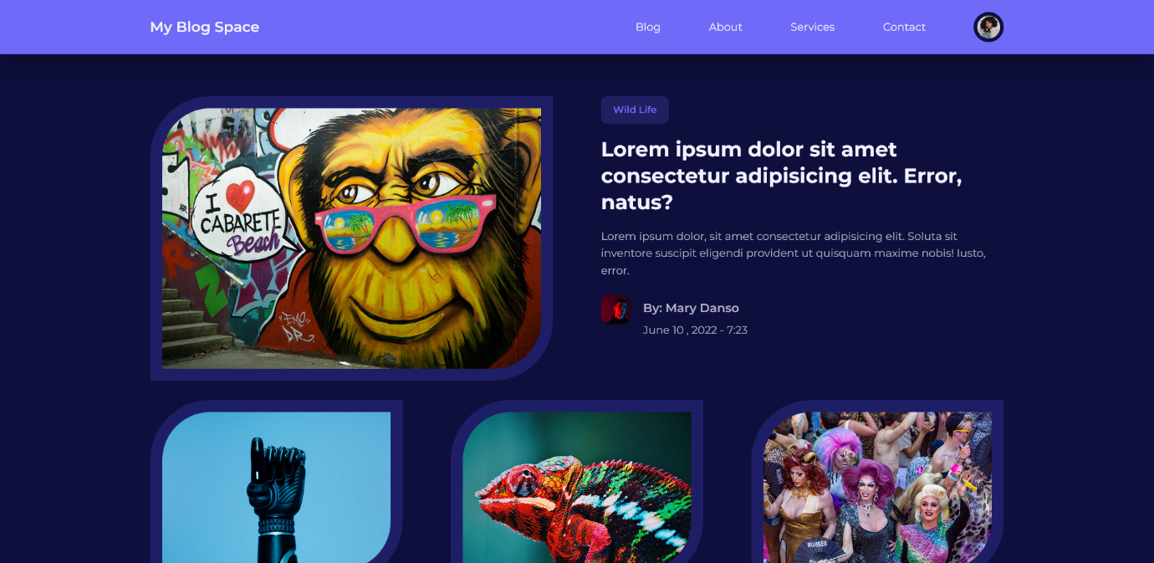

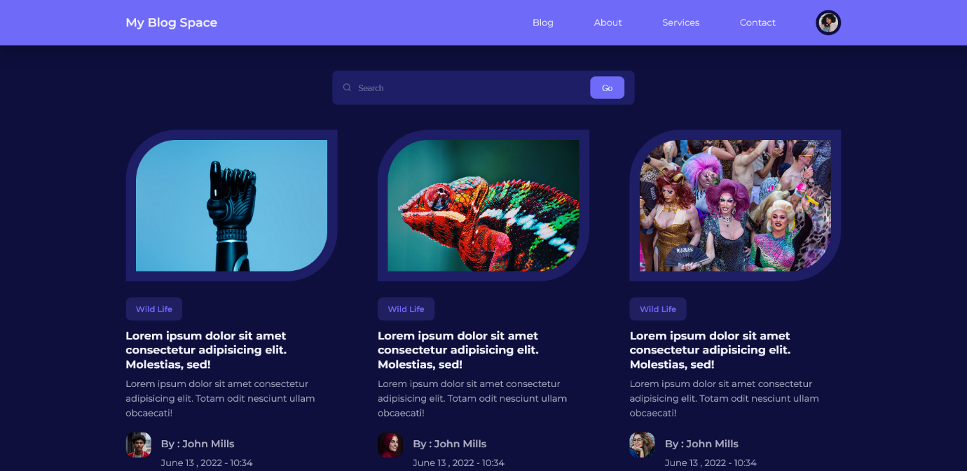

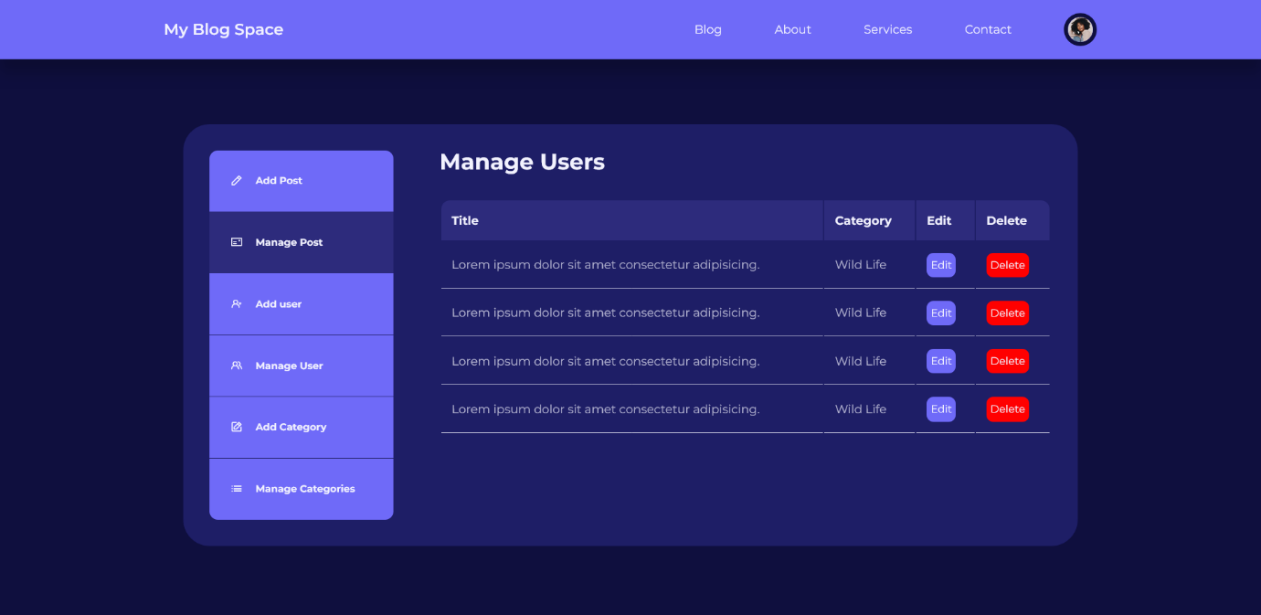

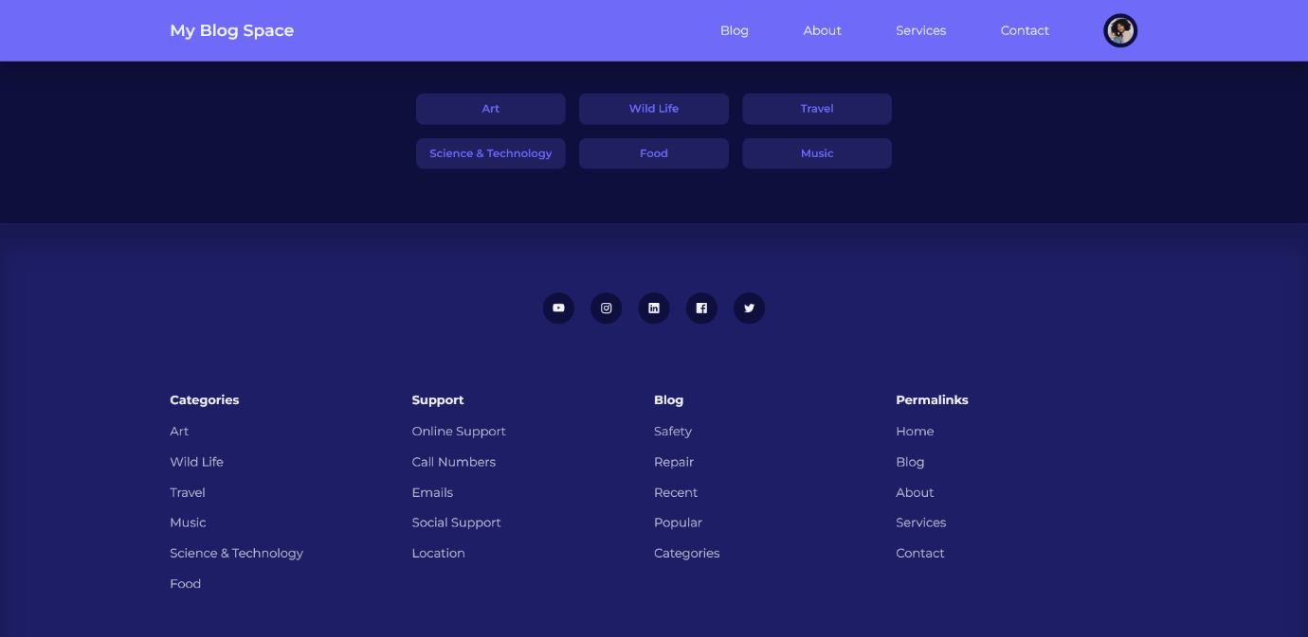

**References**

* <https://fonts.googleapis.com/css2?family=Montserrat:ital,wght@0,100..900;1,100..900&display=swap>
* <https://unicons.iconscout.com/release/v4.0.8/css/line.css>
* <https://fonts.googleapis.com>
* <https://fonts.gstatic.com>
* <https://youtube.com>
* <https://hugeicons.com>